categories.

6. Now open the Profiling page. You should see profiler messages, as shown in the following screenshot:

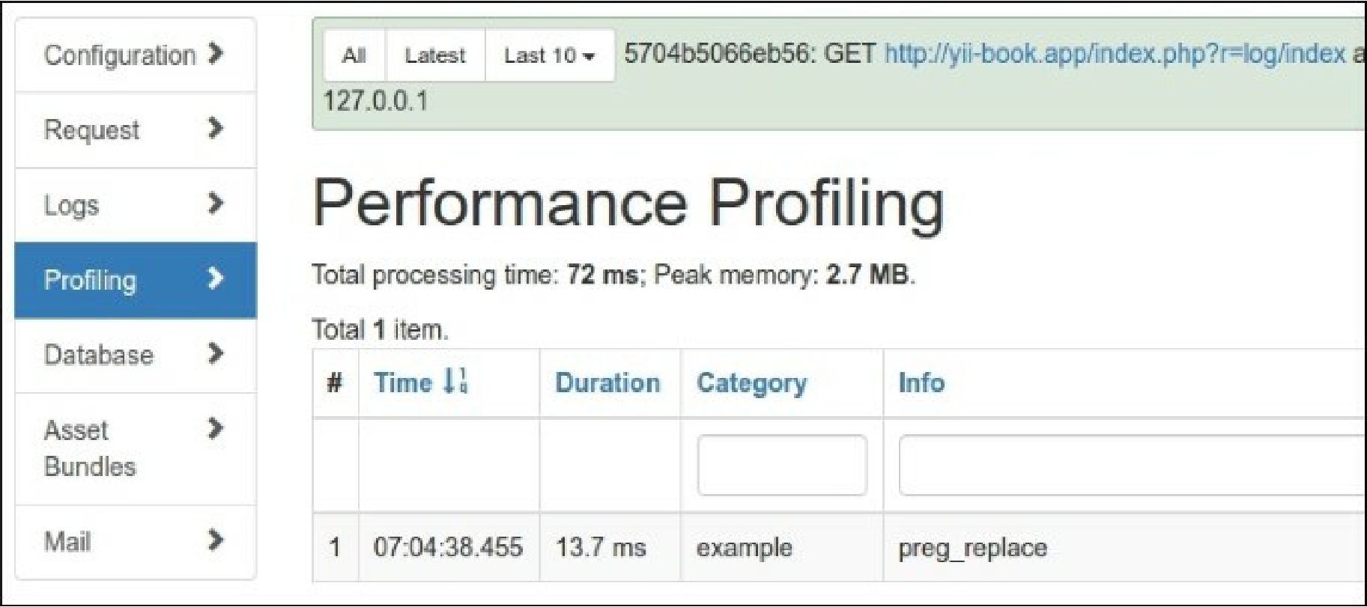

Profiling info displays the total executing duration of own code block.

1. As we just changed the log file names and not the paths, you should look in runtime/logs to find log files named error . log, warning . log, and info . log.
2. Inside, you will find the following messages:

**2016-03-06 07:28:35 [127.0.0.1][-][-][error][example] error**

**2016-03-06 07:28:35 [127.0.0.1][-][-][warning][example] warning**

**2016-03-06 07:28:35 [127.0.0.1][-][-][info][example] inf o**

How it works...

When one logs a message using Yii: :erorr, Yii: :warning, Yii: : info, or Yii: :trace, Yii passes it to the log router.

Depending on how it is configured, it passes messages to one or many targets, for example, e-mailing errors, writing debug information in file A, and writing warning information in file B.

The object of the yii\log\Dispatcher class is typically attached to an application component named log. Therefore, in order to configure it, we should set its properties in the configuration file components section. The only configurable property there is targets that contains an array of log routes and their configurations.

We have defined four log routes. Let’s review them as follows: